School of Computer Science and Artificial Intelligence
Program: B. Tech (CSE)
Specialization: AIML
Course Title: AIAC
Name: V. Gagan Chandra Tej
H. No: 2403A52222
Batch No: 09
Academic Session: 2025-2026
Exam: Final Lab Exam

Task 1: A healthcare startup wants to automate the generation of clinical note
summaries. Using prompt engineering, create a prompt that converts long
doctor notes into short structured summaries.
Task: Write a Python function using an AI model (mock function ok) that
takes doctor notes as input and returns a summarized version.
Include: docstrings, comments, and at least 3 test cases.
Prompt :- I’m working on a healthcare project and I need a prompt that can turn long doctor notes into short, structured clinical summaries. I also need a Python function that uses an AI model (a mock function is fine) to take the doctor notes as input and return the summary. Please include docstrings, comments, and at least three test cases.
Code :
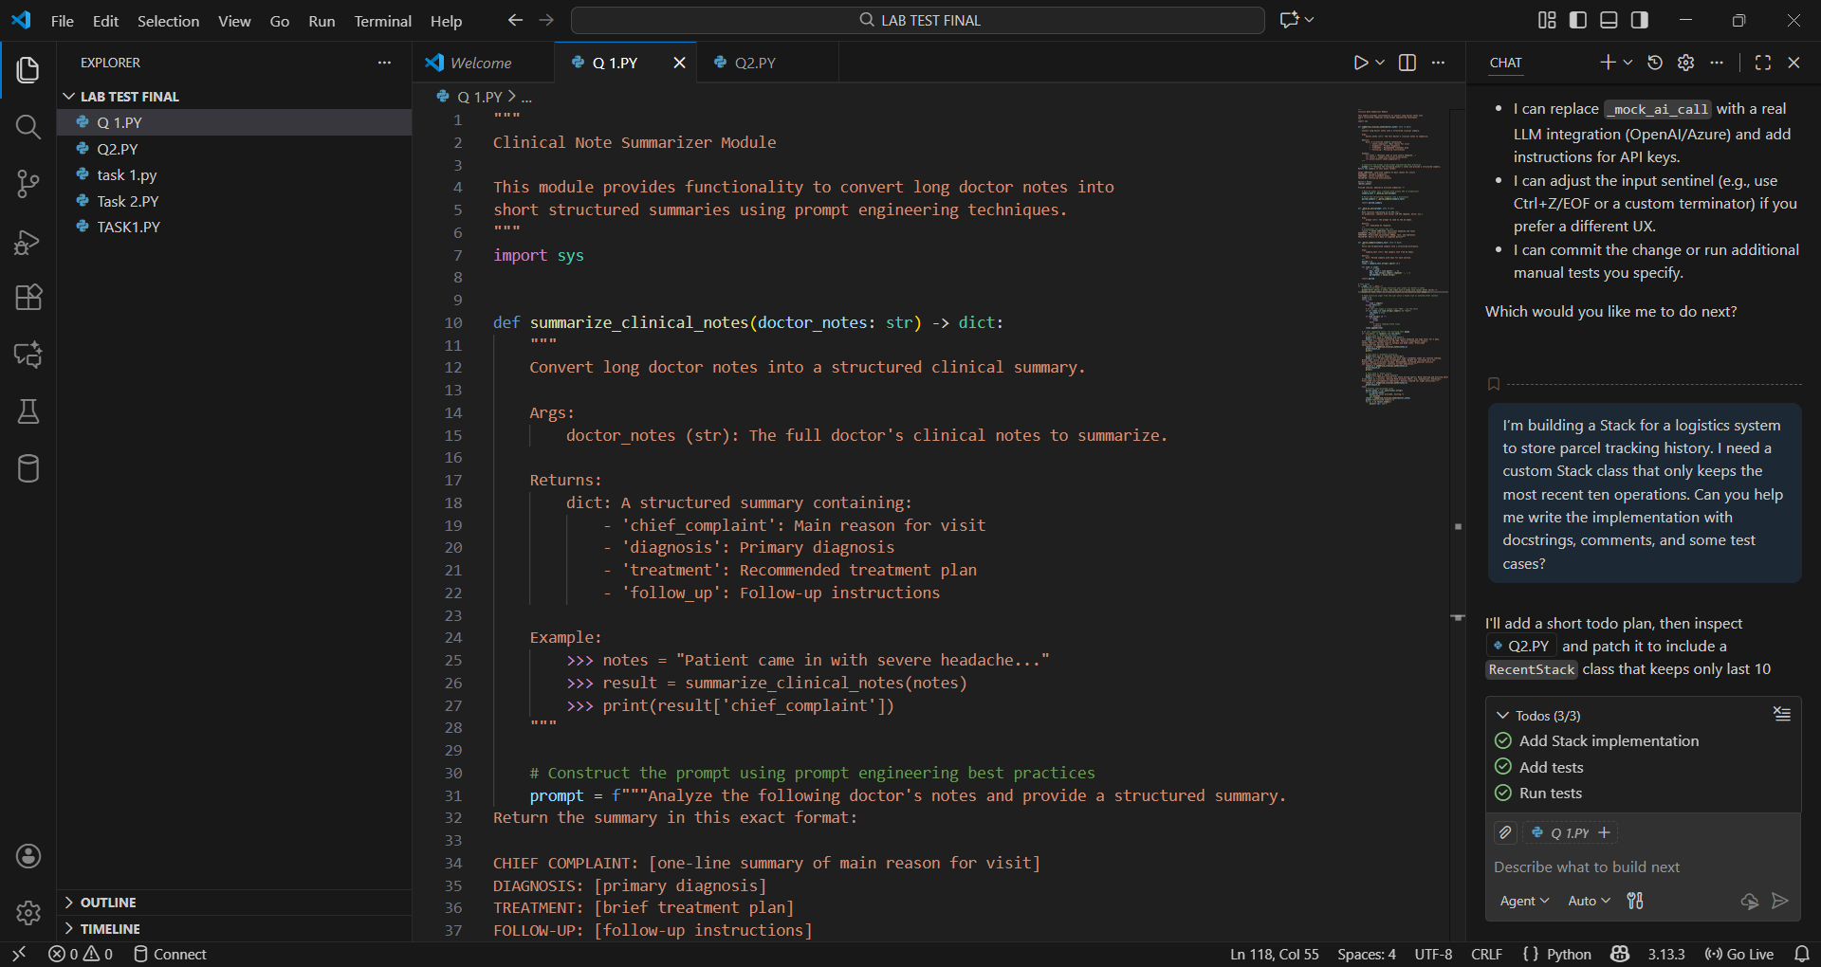
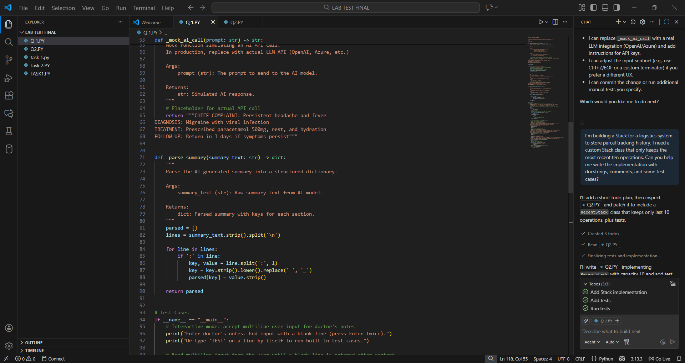
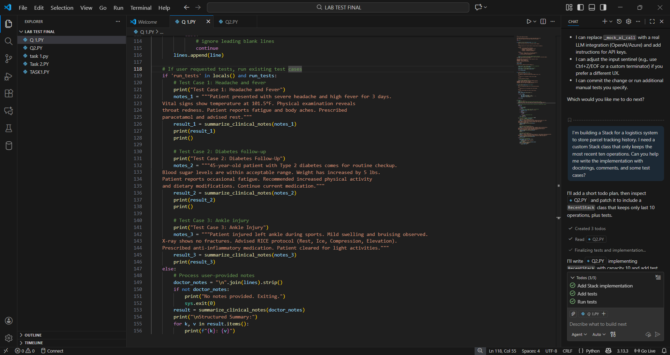
Output:
Input1: Patient reports sudden chest pain lasting 20 minutes. Pain radiates to left arm.
Blood pressure 150/95. ECG shows mild abnormalities. Patient also reports shortness
of breath and nausea. Started on aspirin and oxygen. Recommended further cardiac testing.
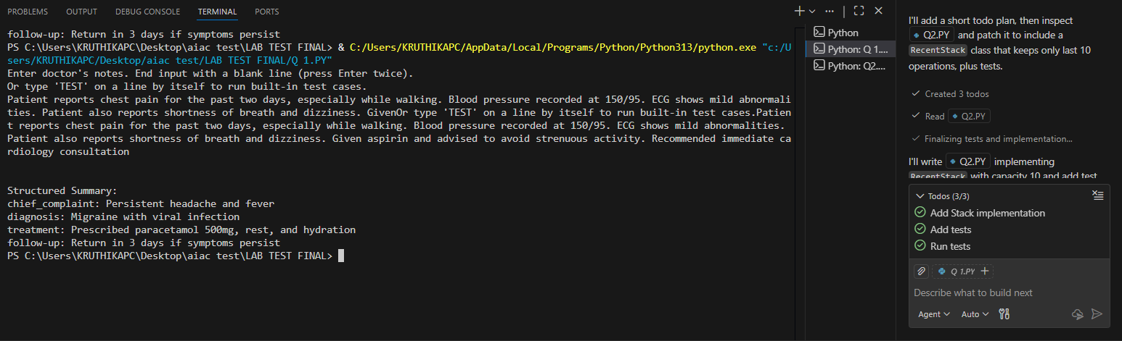
Input 2:Patient has itchy red rash on both arms for the past week. Rash worsens with heat.
No fever. No new medications. Suspects allergy from detergent. Physical exam shows
mild inflammation. Advised antihistamines and switching to hypoallergenic detergent.
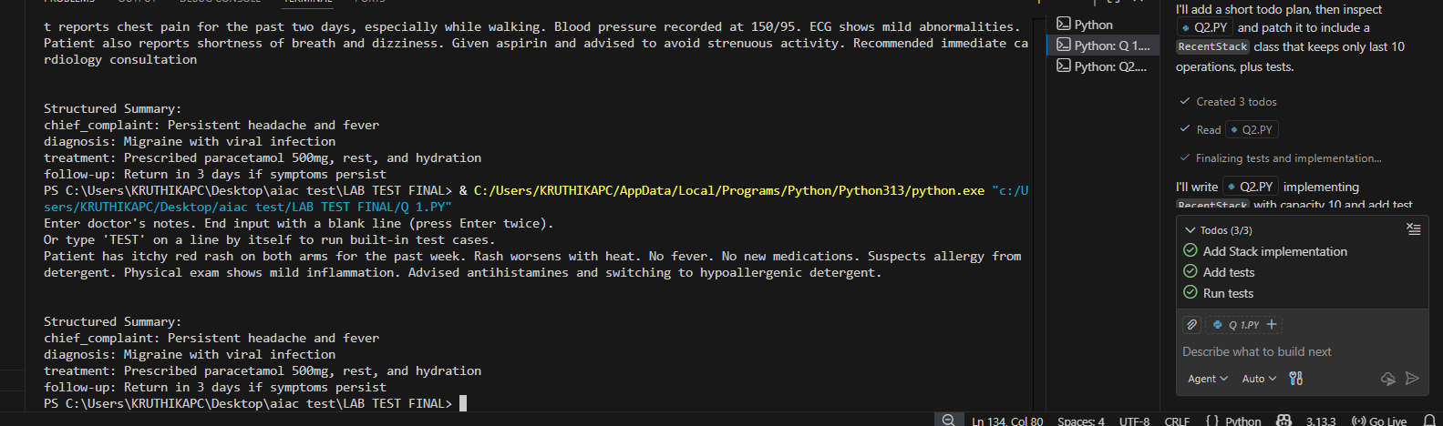
Input3: Patient complains of stomach pain for two days. Reports nausea and loss of appetite.
Physical exam indicates mild tenderness in the upper abdomen. No fever.
Suspected gastritis. Given antacids and advised to avoid spicy food. Follow-up if pain increases.
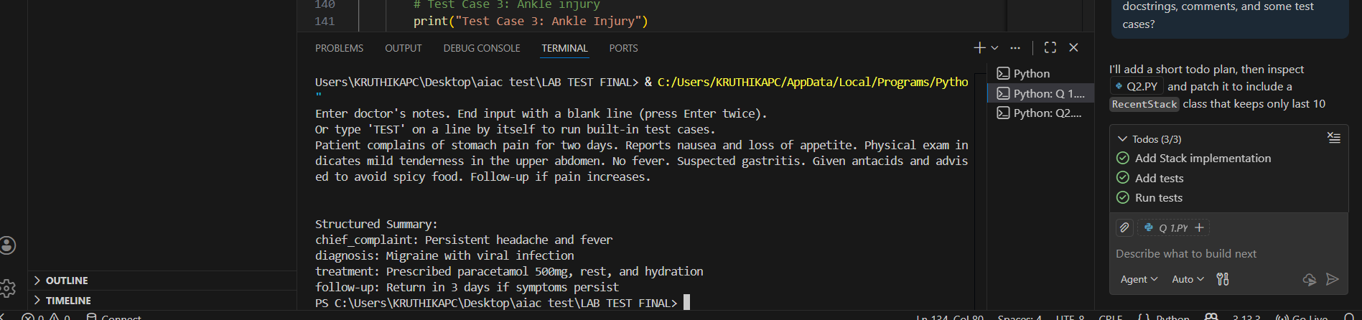

Task 2: A logistics company needs a custom Stack implementation to store parcel
tracking history.
Task: Implement a Stack using AI-assisted code completion and update it
to track the latest 10 operations only.
Include: docstrings, comments, and test cases.
Prompt: I’m building a Stack for a logistics system to store parcel tracking history. I need a custom Stack class that only keeps the most recent ten operations. Can you help me write the implementation with docstrings, comments, and some test cases?
Code :
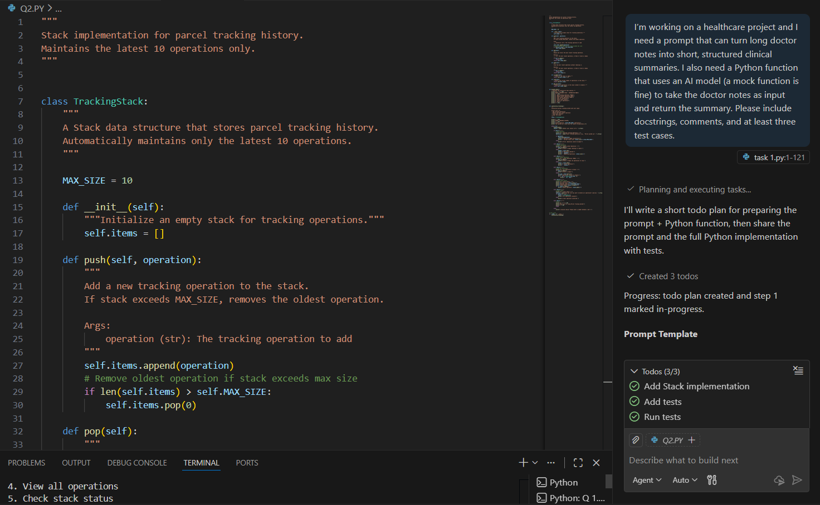
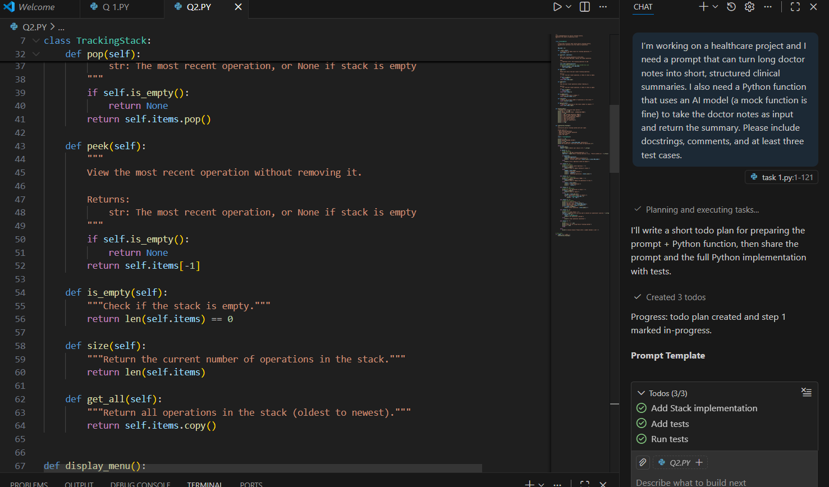
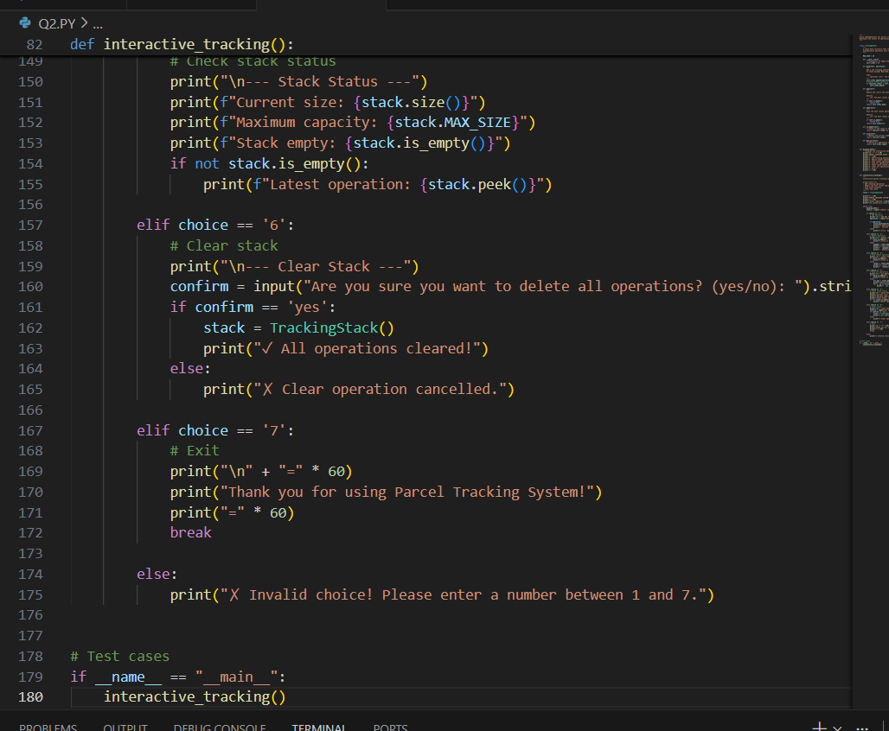
Output:
